What’s the Complexity? | 2D Image Assessment

Response Record: Common Objects

Student: Response Method (circle one): identification recognition

Indicate correct answers with a checkmark. If incorrect, write student’s approximation.

Color Photograph

Image | Date: | Date: | Date: | Date: | Date:
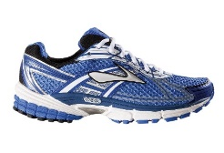


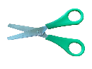


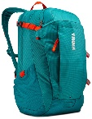


Average:
Complexity Level

100% = Comfortable 60% - 99% = Challenging 0% – 59% = Frustrational

What’s the Complexity? | 2D Image Assessment

Response Record: Common Objects

Student: Response Method (circle one): identification recognition

Indicate correct answers with a checkmark. If incorrect, write student’s approximation.

Realistic Color Illustration

Image | Date: | Date: | Date: | Date: | Date:
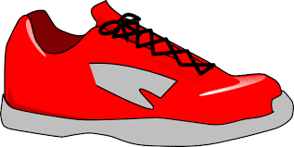


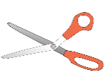






Average:
Complexity Level

100% = Comfortable 60% - 99% = Challenging 0% – 59% = Frustrational

What’s the Complexity? | 2D Image Assessment

Response Record: Common Objects

Student: Response Method (circle one): identification recognition

Indicate correct answers with a checkmark. If incorrect, write student’s approximation.

Abstract Color Illustration

Image | Date: | Date: | Date: | Date: | Date:
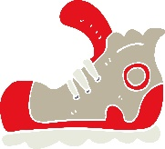








Average:
Complexity Level

100% = Comfortable 60% - 99% = Challenging 0% – 59% = Frustrational
What’s the Complexity? | 2D Image Assessment

Response Record: Common Objects

Student: Response Method (circle one): identification recognition

Indicate correct answers with a checkmark. If incorrect, write student’s approximation.

Realistic Black and White Illustrations

Image | Date: | Date: | Date: | Date: | Date:
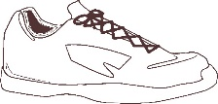


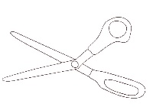

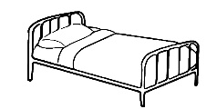
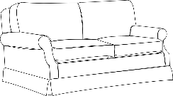
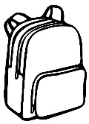

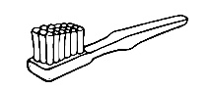
Average:
Complexity Level

100% = Comfortable 60% - 99% = Challenging 0% – 59% = Frustrational

What’s the Complexity? | 2D Image Assessment

Response Record: Common Objects

Student: Response Method (circle one): identification recognition

Indicate correct answers with a checkmark. If incorrect, write student’s approximation.

Abstract Black and White Illustrations

Image | Date: | Date: | Date: | Date: | Date:
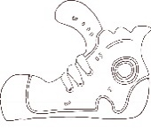




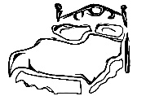
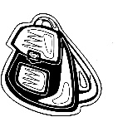
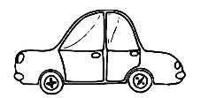

Average:
Complexity Level

100% = Comfortable 60% - 99% = Challenging 0% – 59% = Frustrational

